**Demand forecasting and management**

Demand forecasting and logistics management refer to predicting and effectively managing the demand for products or services within the context of a logistics or supply chain operation. It involves understanding customer demand patterns, aligning inventory levels, optimizing transportation and distribution, and ensuring timely and accurate delivery to meet customer needs.

Some of the key aspects are Demand Forecasting, Inventory Management, Transportation planning, Warehouse and distribution management, Collaboration and communication.

**Applications of AI in demand forecasting**

**Advanced Analytics:**

AI-powered demand forecasting uses sophisticated algorithms to analyse large volumes of historical and real-time data, including sales data, market trends, weather patterns, social media sentiment, and more. Machine learning models can identify patterns, correlations, and seasonality in the data to generate accurate demand forecasts. This helps logistics managers make informed decisions about inventory planning, transportation capacity, and resource allocation.**Demand Sensing**

 AI can capture and analyse real-time data from various sources, such as point-of-sale systems, online sales platforms, and social media, to sense changes in demand patterns. By continuously monitoring and analysing this data, AI algorithms can quickly detect shifts in consumer behaviour, emerging trends, and demand fluctuations. This enables logistics managers to respond promptly and adjust their operations accordingly.**Predictive Maintenance**

 In logistics, predictive maintenance utilizes AI algorithms to analyse equipment sensor data, historical maintenance records, and other relevant information to predict when maintenance is required. By identifying potential equipment failures or performance issues in advance, logistics managers can schedule maintenance activities proactively, minimize unplanned downtime, and ensure the availability of critical assets for meeting demand.**Intelligent Routing and Optimization**

 AI-based algorithms can optimize logistics operations by dynamically determining the most efficient routes, modes of transportation, and load consolidation. By considering factors such as traffic conditions, fuel costs, delivery time windows, and capacity constraints, AI systems can generate optimal transportation plans that minimize costs, reduce delivery times, and improve overall supply chain efficiency.**Autonomous Vehicles and Drones**

 AI-enabled autonomous vehicles and drones have the potential to transform logistics operations. Self-driving trucks and drones can automate transportation tasks, reducing dependency on human drivers and improving delivery speed and efficiency. AI algorithms power autonomous vehicles by processing real-time sensor data, interpreting traffic conditions, and making intelligent decisions to navigate safely and optimize routes.**Chatbots and Virtual Assistants**:

AI-powered chatbots and virtual assistants can assist in demand forecasting and management by providing real-time information and responding to customer inquiries. These AI systems can handle customer queries about product availability, order status, and delivery updates, providing a seamless and personalized customer experience. By automating customer interactions, logistics managers can focus on strategic decision-making

**Operations Optimization**

A company that does not analyse the data faces many challenges, primarily because of unnecessary costs. They can have incomplete trucks, avoidable logistic operations, or inefficient technical mending. As a result, they will lose money and time in the process.

Moreover, AI can analyse all the data from unsuccessful operations and predict activities for improving the process. It could be decreasing in fleet size, leasing, parking, and driving costs. For example, courier company Speedy from Bulgaria reduced hub-to-hub costs by 25% by implementing AI technology in logistic demand. They used augmented intelligence to detect unnecessary transportations and cancelled them imminently.

**Increase Employee Efficiency**

AI algorithms can predict the granular demand for every origin-destination, and it will help to save time for the employees. In case the employees have more time and ready decision in planning the logistic activities, they can be more efficient in operations.

AI also can compare the planning decisions made by humans and algorithms and use this data for future machine learning. In some way, it will also improve the demand forecasting and help to make accurate decisions during the logistic process. For example, the AI can define if the drivers need to take a break or finish the chain. With numbers and data analysis, this decision helps to optimize employee efficiency and rationalize time spent.

**Optimal Fleet Repositioning**

It can be difficult for the company to manage all trucks, containers, and space they use, mainly if the company works in different countries and has thousands of units. In this case, implementing artificial intelligence for planning the company’s work and utilizing all resources to carpathite is the best option.

For example, the TIO trailer service works in 70 locations in Europe. Their problem was in fleet management. After implementing AI technology, they could respond to asset demand more carefully. This analytical work increased the income by 11% and made the company more flexible for the clients.

**Selling Extra Logistics Assets**

The biggest problem for logistics is not to use any available space in trucks. Half of the trucks in the EU were traveling empty on their way back after delivery. For business, it means that the trucks are losing money while they have a chance to earn them. The problem can be solved with AI for optimizing operations in logistics and planning the activities.

At the same time, logistic operators need to have safe stocks of assets everywhere. If the AI will optimize the operations and companies could solve the activities they do not need. With demand forecasting, the company will know which assets they will need and rent for a time. The AI goal to optimize the supply chain can improve the usage of different assets and define the pick periods when they can lease their assets.

**Dynamic Pricing**

The next benefit of using AI in demand forecasting is the ability to form dynamic pricing for services. Many circumstances influence the cost of logistics, such as seasonality or the contract that will cause the empty returning of trucks.

With AI, the company can form the price for every case and be sure that all possible facts of the inevitable logistic process were taken into consideration. This model of demand forecasting is essential for business and its competitive abilities.

The ability to have dynamic pricing is one of the most valuable benefits in predicting the activities, as it helps to save money and be flexible in managing the cost for the clients.

**Advantages of AI Applications in AI Demand forecasting:**

Improved Accuracy: AI provides more accurate demand forecasts, reducing errors.Real-Time Insights: AI captures and analyses real-time data for agile decision-making.Enhanced Forecasting Models: AI algorithms identify complex patterns and adapt to changing dynamics.Demand Sensing and Adaptability: AI detects shifts in demand and enables prompt adjustments.Optimal Resource Allocation: AI optimizes resource utilization, reducing costs.Intelligent Routing and Delivery Planning: AI generates optimal routes and improves delivery efficiency.Predictive Maintenance: AI predicts equipment failures, minimizing downtime.Continuous Learning and Improvement: AI learns from new data, refining its forecasting models.

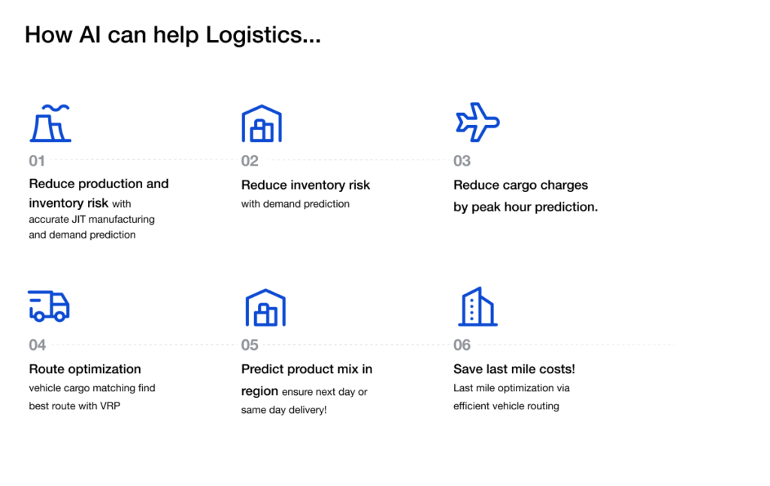

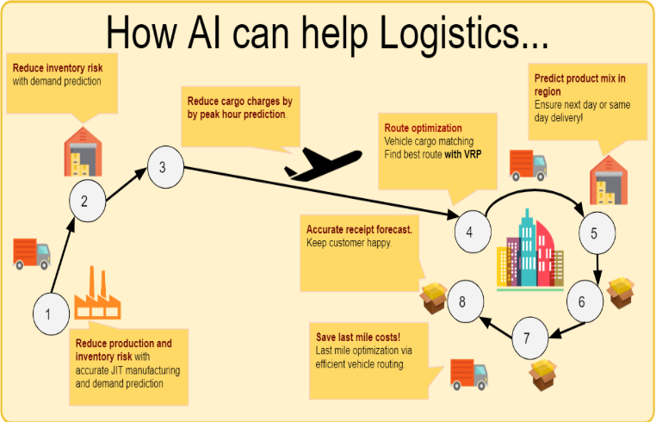

**Disadvantages of AI in Demand Forecasting**

Dependency on Data Quality: AI algorithms heavily rely on the quality and availability of data. Inaccurate or incomplete data can lead to unreliable forecasts and inaccurate decision-making. Data cleaning and validation processes become critical to ensure the accuracy of AI-driven demand forecasts.**Complexity and Implementation Costs**: Implementing AI systems for demand forecasting requires expertise in data analytics, machine learning, and AI technologies. The complexity of AI implementation may lead to higher upfront costs, including infrastructure setup, data integration, and training of personnel.**Need for Skilled Personnel**: Utilizing AI for demand forecasting and management necessitates skilled personnel with expertise in data analysis, machine learning, and AI algorithms. Companies may face challenges in recruiting and retaining talent with the necessary skills, which could impact the successful implementation and utilization of AI systems.**Lack of Transparency**: Some AI algorithms, such as deep learning neural networks, can be considered "black boxes" as they provide predictions without clear explanations. The lack of transparency in AI models may make it difficult for users to understand the reasoning behind forecasts, leading to potential scepticism or reluctance in fully trusting AI-driven predictions.**Vulnerability to Data Biases**: AI algorithms can be influenced by biases present in the training data, leading to biased forecasts. If historical data contains inherent biases or if the training data is not representative of the current market conditions, it can result in skewed forecasts that may not accurately reflect the actual demand patterns.**Overreliance on Automation**: The automation capabilities of AI may lead to overreliance on AI-driven decisions without human intervention or oversight. It is important to strike a balance between automation and human judgment to ensure that strategic insights and contextual knowledge are considered alongside AI-generated forecasts.**Potential Security Risks**: Implementing AI systems in demand forecasting and management requires secure handling of sensitive data. The increased reliance on AI and the connectivity of systems can introduce new cybersecurity risks, making it crucial to implement robust security measures to protect data privacy and prevent unauthorized access.

**Conclusion**

As we can see from all the digitization benefits, logistic demand forecasting is a complicated but efficient instrument. We incorporate artificial intelligence in developing the best decision options and the human brain for the final decision to use or not this plan or action. The combination of the two approaches is the best way for technical supply and activity prediction.